* **Virtualization:**
* Virtualization is the installation of multiple operating systems in a single hardware.
* Virtualization uses software to create an abstraction layer over computer hardware that allows the hardware elements of a single computer—processors, memory, storage and more—to be divided into multiple virtual computers, commonly called virtual machines (VMs).
* Each VM runs its own operating system (OS) and behaves like an independent computer, even though it is running on just a portion of the actual

underlying computer hardware.

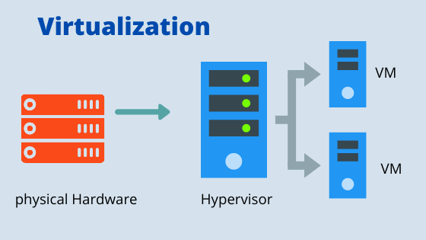

**Types of Virtualization :**

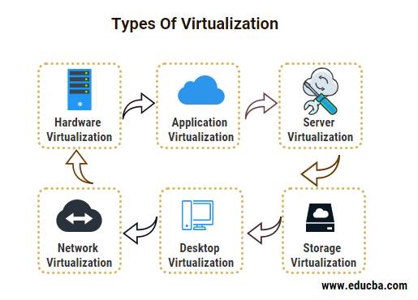

#### **Desktop Virtualization**

* This type of virtualization also known as VDI (virtual desktop infrastructure) was in our operating system will be running like a virtual machine on a server along with other VD (virtual desktops).
* For the processing of these VD’s, we will be doing it in a data center with the help of physical servers
* The multiple applications and operating systems that are being used by the end-user will be cached in the memory on the server
* As of today couple of major virtualization vendors are Citrix and VMware Horizon,

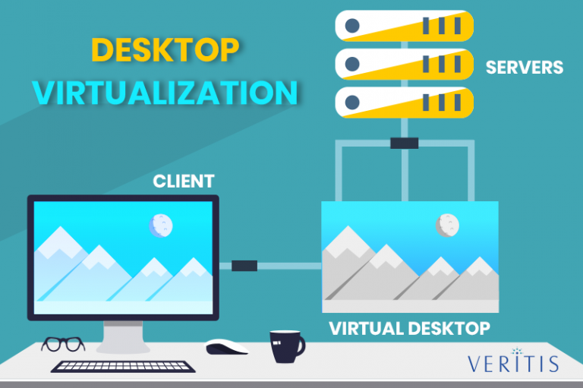

#### Application Virtualization:

* Application virtualization can further be divided into two categories they are:
* **Remote:** In this type of application virtualization, the client will be using a display protocol that is remote for the purpose of communicating to the client machine.

* **Streaming:** The beauty of this kind of application virtualization is that we will be able to have a copy of the app on our server and we can have them run parallel in the local systems of client.

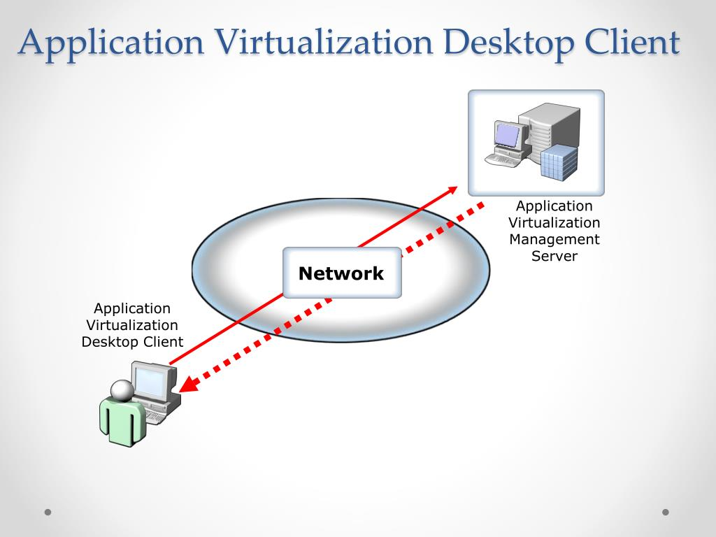

#### **Server Virtualization :**

* In this type of virtualization, we aim to virtualize the server that we use, that is we will be running multiple VM’s (virtual machines) in a single physical server
* Here the resource form this physical server will be shared among all the virtual servers that are being used.
* Some of the resources which are being shared majorly are CPU, Storage, ROM, and RAM, etc
* we will be sharing them on the hypervisor
* These virtual machines are isolated and independent of each other and they are completely capable of running the different OS in different machines.

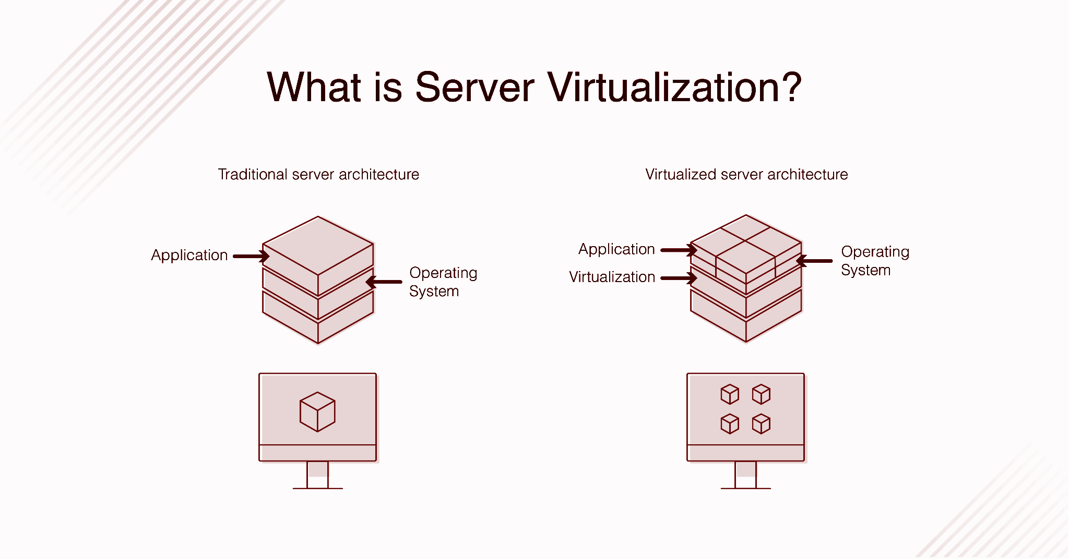

* What is RedHat Linux

**Linux :**

Linux is an [open source](https://www.redhat.com/en/topics/open-source/what-is-open-source) operating system (OS). An [operating system](https://www.redhat.com/en/technologies/linux-platforms/old-enterprise-linux) is the software that directly manages a system’s hardware and resources, like CPU, memory, and [storage](https://www.redhat.com/en/topics/data-storage/software-defined-storage).

**Redhat Linux** :

* Red Hat Linux was a widely used commercial open-source Linux distribution created by Red Hat until its discontinuation in 2004. Early releases of Red Hat Linux were called Red Hat Commercial Linux.
* Red Hat published the first non-beta release in May 1995.
* It was the first Linux distribution to use the [RPM Package Manager](https://en.wikipedia.org/wiki/RPM_Package_Manager) as its packaging format, and over time has served as the starting point for several other distributions, such as [Mandriva Linux](https://en.wikipedia.org/wiki/Mandriva_Linux) and [Yellow Dog Linux](https://en.wikipedia.org/wiki/Yellow_Dog_Linux).
* In 2003, Red Hat discontinued the Red Hat Linux line in favor of [Red Hat Enterprise Linux](https://en.wikipedia.org/wiki/Red_Hat_Enterprise_Linux) (RHEL) for enterprise environments.
* [Fedora Linux](https://en.wikipedia.org/wiki/Fedora_Linux), developed by the community-supported [Fedora Project](https://en.wikipedia.org/wiki/Fedora_Project) and sponsored by Red Hat, is a free-of-cost alternative intended for home use.
* Red Hat Linux 9, the final release, hit its official end-of-life on April 30, 2004,

# **How to Install Ubuntu on VMware Workstation 17 Pro**

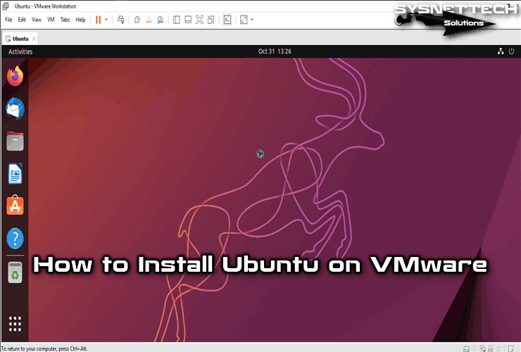

* VMware Workstation is the most popular Hypervisor Type 2 virtualization program developed by the VMware company.
* we will examine how to run Ubuntu on a new virtual machine using the VMware Workstation virtualization program on the Windows operating system.

**Installation Process:**

* Before installing the ubuntu file, we need to install the VM workstation.

**Steps involve in Installation:**

1. Go to Ubuntu workstation official website.

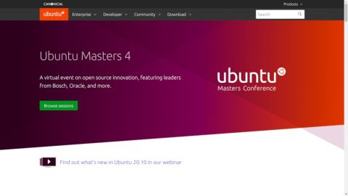

1. We need to download the Ubuntu file.

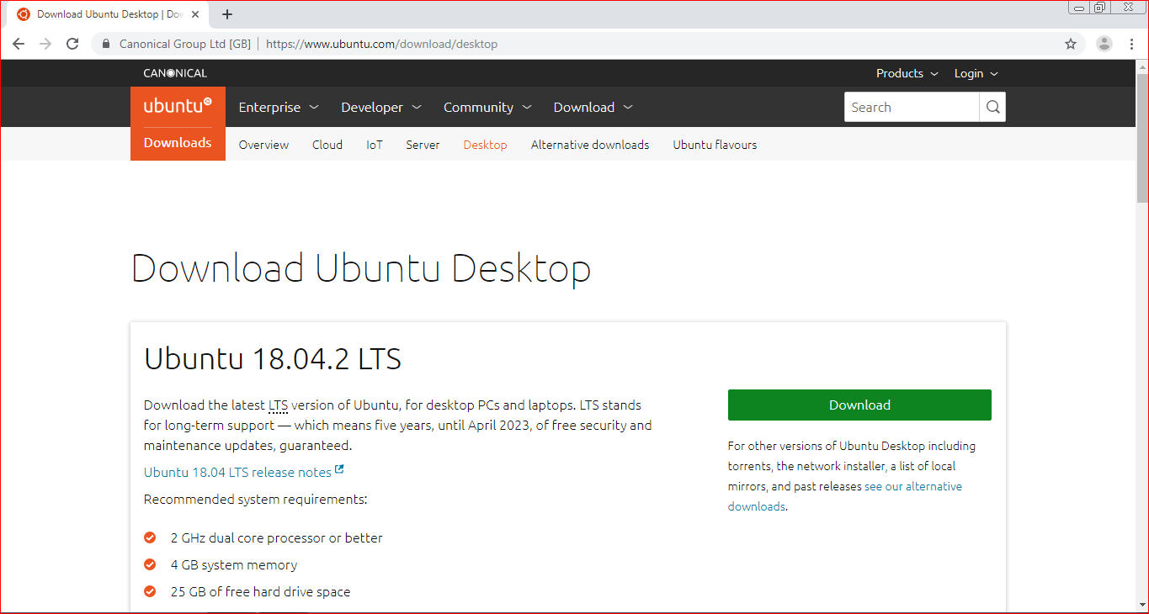

1. Open the ubuntu file.

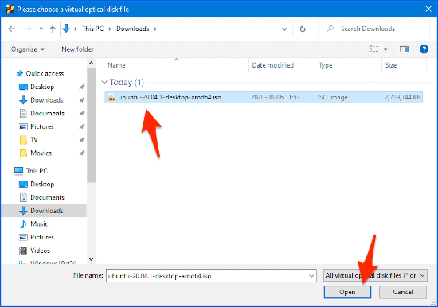

1. Click the Custom option.

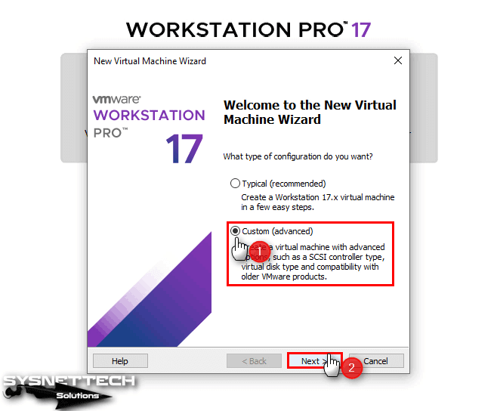

1. Configure the hardware compatibility setting of the virtual machine as Workstation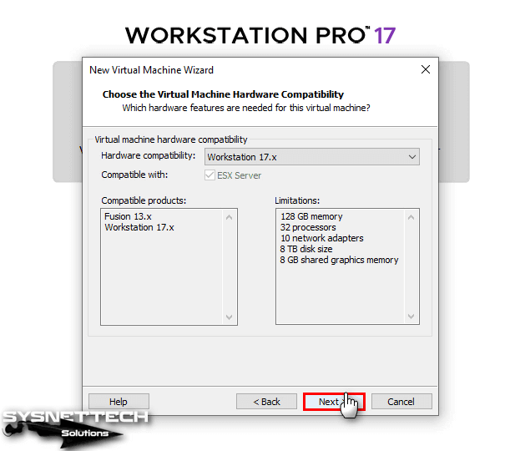
2. In the Guest Operating System Installation window, select “I will install the operating system later” and click the Next button.

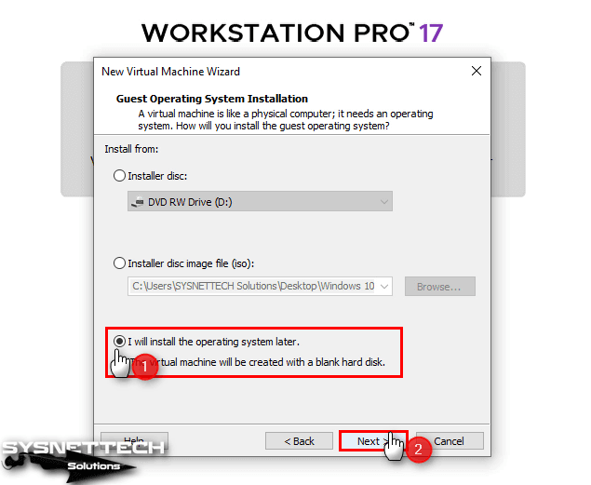

1. In the Guest OS selection window, select the Linux / Ubuntu and click Next.

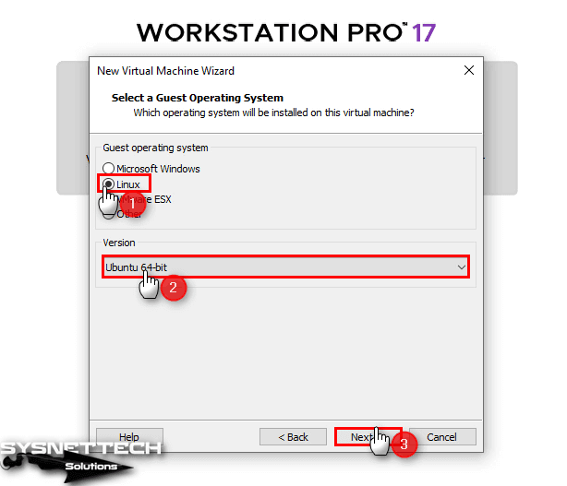

1. If your physical computer has high storage capacity, you can install your virtual system in the default location.

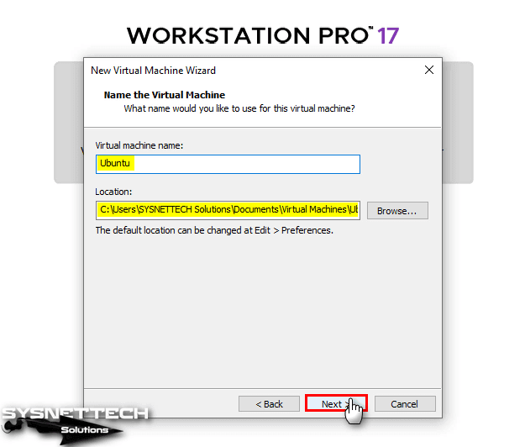

1. According to the hardware features of your computer, you can add one or more virtual processors for the Ubuntu virtual machine and increase the virtual core value.

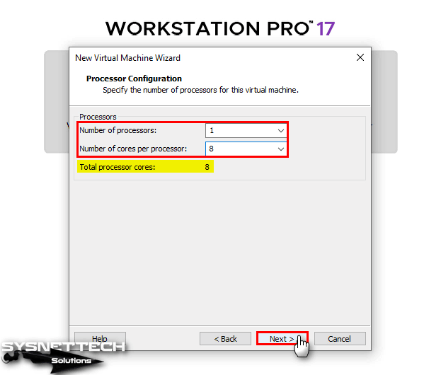

1. In the same way, set a value suitable for the memory capacity of your host for the Ubuntu virtual computer. You can automatically determine the maximum memory value of the program by clicking the blue arrow in the Memory for the Virtual Machine window.

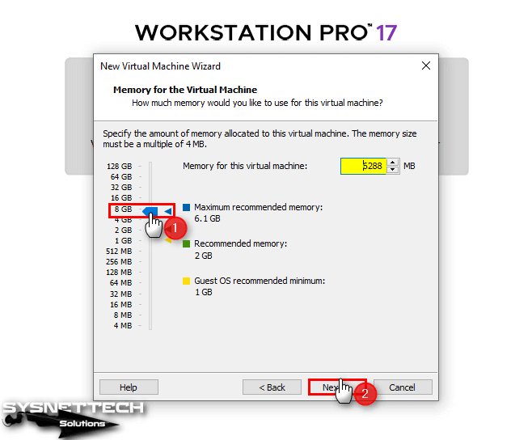

You can configure the network adapter settings of the virtual machine that will run on VMware according to your personal preferences or according to your project.

1. Select the default [NAT](https://www.sysnettechsolutions.com/en/vmware-workstation-nat-configuration/) for the network adapter and click Next.

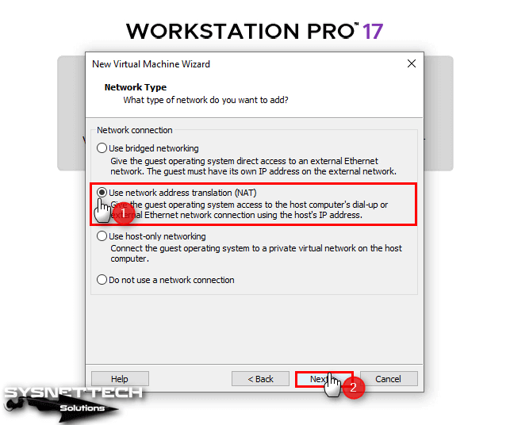

1. Continue with the LSI Logic option selected by default in the I/O Controller window.

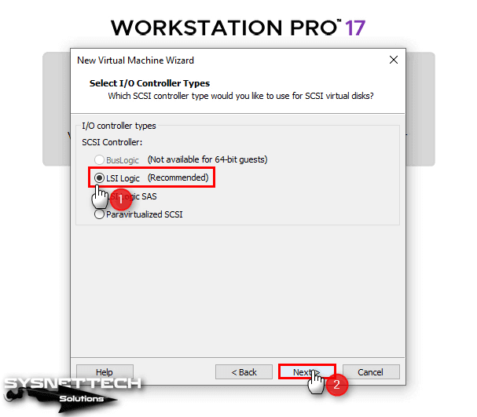

1. In the Disk Type window, select NVMe instead of the default SCSI type and continue.

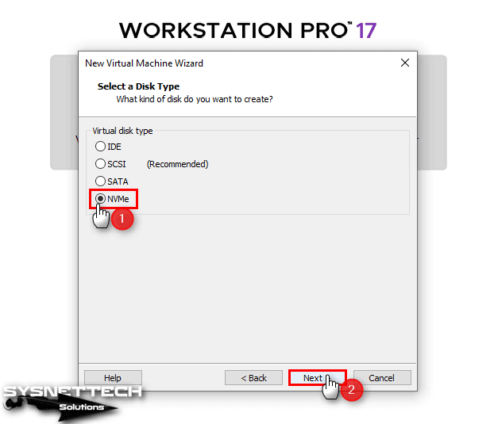

1. You must create a new virtual disk with the Create a New Virtual Disk

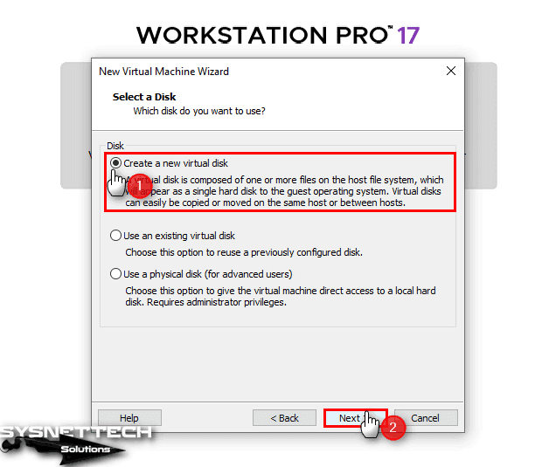

1. Select Store virtual disk as a single file to back up the virtual hard disk as a single file.

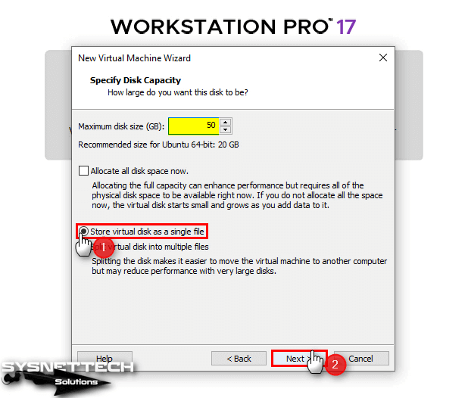

1. After creating your Ubuntu guest machine, review the summary hardware information and click Finish.

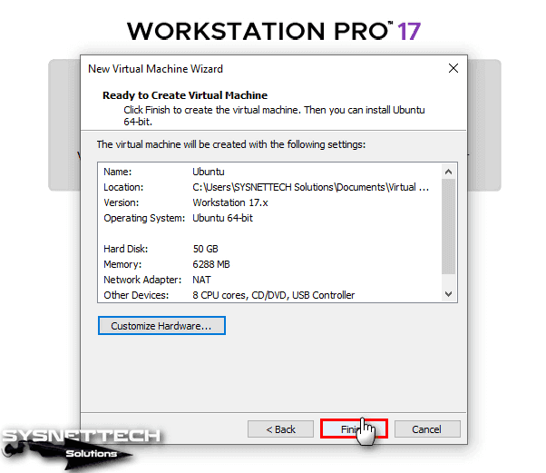

* **Linux Fundamentals Commands :**

**Commands:**

* **PWD** - Present working directory
* **CD** - Change directory
* **Mkdir**- Create new directory
* **Touch**- Create the empty file
* **Cat** - Display the content of file
* **Cat>filename** - Create the file and enter the content into the particular file name
* **Cat-n** - Used to write the content in another file
* **Cat file1file2>file3** - Create the new files(file 1 and file 2) and copies the contant of bothfile.
* **LS** - list of files
* **LS*.txt** - List all the file with given extension.
* **Cp** - Copy a file or directory.
* **MV** - Move a file or directory
* **Head** - Display the first 10 lines
* **Tail** - Display the last 10 lines
* **More** - Display the next lines
* **ID** - Display the id of user or group
* **Clear** - Remove the content
* **Vi** - Text editor
* **Grep** - Filter to search the given pattern in file name
* **Diff** - Compares the content of two different files.
* **Ping** - Check the connection status
* **History** - Display the commands which we use
* **Hostname** - Display the hostname
* **Hostname-i** - Display host ip address
* **Chmod** - Uses to change the user or group permission to access File.
* **Nl** - Display the line number
* **Wc** - Displays the no of lines, words and characters available in contant
* **Uniq** - Remove duplicate of file content
* **Rmdir** - removes specific directory.
* **Rm** - Removes the file.
* **Man** - Displays the all commands status.
* **Echo** - Used to display any terminal.
* **Whoami** - Shows the current user
* **Sudo** - Used to add the user with authentication we use sudo.
* **Sudo userdel** - Used to delete a user which has an authentication.
* **Sudo groupadd** - Used to create a group.
* **Sudo groupdel** - delete the group.
* **Sudo bash** - Switch to the root user
* **Nano** - It is same as cat but used to save directory and write information in that directory.
* **Chown** - Used to change ownership of user server and security.
* **Ls of** - List of open files.
* **Tax** - used to zip or unzip the file.
* **Cut** - Used to extract the portion of the file, using columns and demerits.
* **Sed** - Used to text editor which perform editor operation in non interact way.
* **Watch** - Used to execute a program periodically showing output in fullscreen.
* **Eval** = It is a built-in linux command, which is used to execute arguments in shell command.
* **Dd** - Used to convert or copy files in primary utility.
* **Free** - Displays the amount of free space available along with memory used and swap memory in system and swap memory used.
* **SSH** - Refers cryptographic network protocol for operating network server security.
* **Init o** - used to shutdown the node.
* **Init 6** - Used to Restart the node.
* **DNS** - Used to know domain name service.
* **User and Group Creation + Permissions:**

Command to create User:

* Useradd <filename>

Command to create a Group

* Groupadd <groupname>

Command to give permission

* Chmod
* **Setting up Static IP:**

Steps involve:

1. We need to open the command prompt in our windows.
2. Enter ipconfig /all.
3. Then we will get the interface which contains all the ip addresses.
4. Then go to the control panel.
5. Click on system and security.
6. Click on the open internet option.
7. Go to properties.
8. Click on internet protocol version
9. Then we need to change the obtain ip address to use me

following ip

1. Then get back to command prompt
2. Copy the IPV4 and paste it in setting section of ip address(In

that we need to change the last set to another number)

1. we need to copy the subnet mask which is visible in command

prompt, then copy paste the default gateway.

1. We need to select one of the DNS server(Google IP or

Amazon IP Address) ip address copy paste that ip address

into DNS server section and also mention alternative as well.

1. select validate section
2. Then Click on ok
3. the Static ip address will be setting up.

**Difference between Static and DHCP:**

When you connect to the internet, your device needs an IP address to communicate with other devices.

A Static IP address is like a fixed address manually assigned to your device and never changes.

On the other hand, DHCP(Dynamic Host Configuration Protocol) is a protocol that automatically assigns IP addresses to devices on a network.

| **DHCP** | **Static IP** |
| --- | --- |
| Automatically assigns IP addresses | IP address has to be set manually for each device |
| Addresses can change periodically, causing issues for some applications. | Stable. Do not change unless manually done. |
| Can be centrally managed by a DHCP server. | Require manual configuration and management |
| Can be dynamically assigned as needed, allowing for efficient use of available addresses. | Limited availability, as each device on the network requires a unique IP address |
| Affordable | Generally more expensive |

Hostname and Setting up a new hostname:

Hostname:

A Hostname is an unique, alphanumeric label assigned to a Linux system to identify it on the network.

Command to set the new Hostname

* Hostnamectl (note that this command will only set the computer name temporarily.)

**“The End”**